CSA1413
COMPILER DESIGN
Name: Haresh Kumar N L
Reg No: 192425009
Removal of Comments

Aim:
To write a LEX program to identify and remove both single-line and multi-line comments from a C source program.

Algorithm:
- Start the program.
- Include the required header file.
- Define regular expressions to identify single-line and multi-line comments.
- Open the input C source file and check for errors.
- Scan the file using yylex().
- Ignore single-line comments beginning with //.
- Ignore multi-line comments enclosed within /* and */.
- Print all remaining program content without comments.
- Close the file and stop the program.

Pseudocode:
BEGIN
Include stdio.h
Open the input C file
IF file opening fails THEN
Print error message
EXIT
END IF
WHILE input remains DO
IF single-line comment is found THEN
Ignore the comment
ELSE IF multi-line comment is found THEN
Ignore the comment
ELSE
Print the input unchanged
END IF
END WHILE
Close the file
END

Code:
%{
#include <stdio.h>
%}
%option noyywrap
%%
"//".* ;
"/*"([^*]|\*+[^*/])*\*+"/" ;
\n { ECHO; }
. { ECHO; }
%%
int main(int argc, char *argv[])
{
if (argc != 2)
{
printf("Usage: %s input.c\n", argv[0]);
return 1;
}
yyin = fopen(argv[1], "r");
if (yyin == NULL)
{
printf("Error opening input file!\n");
return 1;
}
yylex();
fclose(yyin);
return 0;
}

Input:
#include <stdio.h>
int main()
{
// This is a single-line comment
printf("Hello World");
/* This is a
multi-line comment */
return 0;
}

Output:
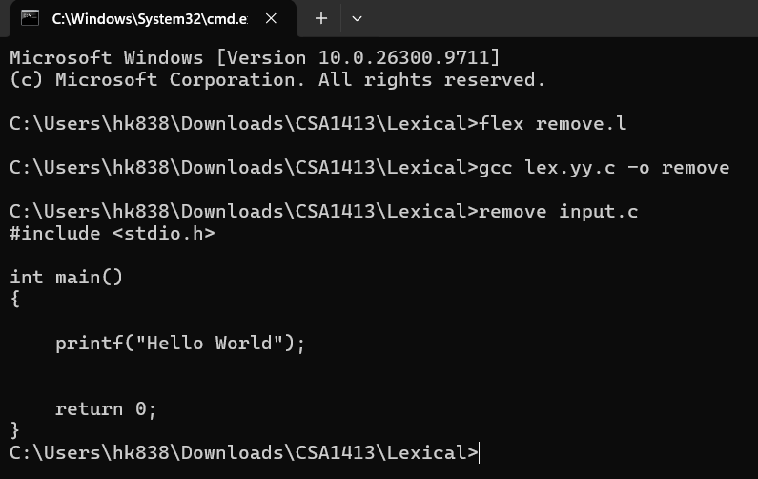
Result:
Thus, the LEX program to identify and remove single-line and multi-line comments from a C source file was written and executed successfully.

